| RESEARCH ARTICLE

Exploring Students and Teachers' Perceptions of AI in English Language Learning: Benefits, Concerns, and Ethical Considerations

Fatima-Zahra Derouach¹, Ouafae Benzizoune², and Ilham Kanina³

¹PhD holder, 'Langage et Société' Laboratory, Faculty of Languages, Letters, and Arts, Ibn Tofail University, Morocco

²Doctoral student, 'Langage et Société' Laboratory, Faculty of Languages, Letters, and Arts, Ibn Tofail University, Morocco

³Doctoral student, 'Langage et Société' Laboratory, Faculty of Languages, Letters, and Arts, Ibn Tofail University, Morocco

Corresponding Author: Author’s Name, Fatima-Zahra Derouach, E-mail: fatimazahra.derouach@uit.ac.ma

| ABSTRACT
The way Artificial Intelligence (AI) has found its way into educational settings has brought new questions to the surface in understanding how it shapes language learning experiences and teaching practices. Therefore, this study investigates the perceptions of teachers and students regarding how AI fits into English language learning. This study adopts a quantitative research approach through the use of two questionnaires distributed to 42 students and 9 teachers. Most students report using AI fairly regularly in their English learning, and the majority acknowledge that it has been helpful to their grasp of the language. While teachers recognize how useful it really is for students, they still express concerns in relation to its use as a form of academic dishonesty. Thus, the study encourages the need for measures to address some worries, for example, implementing AI use guidelines, and providing training for both students and teachers on the ethics of AI. Also, this research suggests involving discussions on academic integrity in AI-based learning environments to improve the responsible and effective use of it in education.

| KEYWORDS

Artificial Intelligence, student perceptions, teacher perceptions, academic integrity, AI in education

| ARTICLE INFORMATION

ACCEPTED: 30 May 2026 PUBLISHED: 23 June 2026 DOI: 10.32996/jeltal.2026.8.8.6

1. Introduction
The rise of Artificial Intelligence (AI) has transformed multiple sectors worldwide, and education is no exception. Within language learning environments, AI has evolved from early Computer-Assisted Language Learning (CALL) applications to advanced generative tools that are capable of providing personalized learning experiences, linguistic feedback, and interactive support (Panagiotidis, 2025). AI technology is thus seen in tools such as ChatGPT, Grammarly, Google Translate, and others in enhancing students’ learning experiences in writing, vocabulary development, and reading comprehension (Ahmed et al., 2025; Karataş, et al., 2024; Khzouz et al., 2024; Song & Song, 2023; Yaseen et al., 2025). Consequently, as AI technology is becoming even more available for use in learning settings, its use in English as a Foreign Language (EFL) learning settings is seen to have increased significantly, thus necessitating a consideration of various factors.
In addition to these benefits, including increased learner engagement and motivation, lower anxiety levels, personalized feedback (Fang, 2025), and enhanced skill development in a perfect environment (Dawson & Targowski, 2004), this research raises critical issues. Research (Çela et al., 2024; Zhai et al., 2024; Zhang et al., 2024) indicates dangers of excessive dependence on AI, diminished critical thought, errors in content generated by AI, and greater chances of academic dishonesty. Interestingly enough, Dovgyi et al. (2024), Barrett and Pack (2023) and Habibulloh (2025) state that students tend to view AI as a source of information, while teachers expect each student to uphold the social contract by doing their own work; students want assistance in completing assignments whereas teachers see the use of it as dishonest; students consider AI help in problem-solving part of learning but for teachers this diminishes the integrity of academic culture. Such views complicate the application of AI in education and thus, necessitate exploring how both groups use and evaluate AI within language learning environments.
  - Research Problem
While AI is becoming part of students’ routine regarding academic practices, educational institutions lack a defined vision of the way in which students and teachers perceive its benefits, limitations, and ethical implications. Indeed, its growing employment for tasks like translation, development of articulation of ideas, the identification and correction of grammar , and even full assignment completion stimulates concern about authenticity, academic honesty, and pedagogical impact (Pan, 2024; Perkins, 2023; Rybina et al., 2025).
1.2. Research Gap
Existing studies could capture the scope of the functional abilities of AI as well as the general attitudes toward it. However, much of the focus is either on students or on teachers, without comparing their views within the same educational context, especially in Morocco. Moreover, previous studies tend to emphasize what AI can do than on how it actually works in real classrooms. (i.e., students actually use AI, what they use it for, and how teachers perceive these practices. Thus, this leaves a gap in understanding how these two pillars of the education setting agree or disagree in their views.
1.3. Research Questions
To address such gap, the study is guided by the following research questions:
- How do students perceive the use, usefulness, and challenges of AI in English language learning?
- How do teachers perceive the role, effectiveness, and risks of AI in their English instruction and students’ learning practices?
- What ethical concerns do students and teachers associate with the use of AI in English learning, particularly regarding academic integrity?
1.4. Research Objectives
Based on these questions, the study:
- Examine students’ use, perceived benefits, and concerns regarding AI instruments in English learning.
- Investigate teachers’ familiarity with, attitudes toward, and observations of AI use in academic settings.
- Compare students’ and teachers’ perceptions to highlight areas of agreement disagreement.
- Provide recommendations for responsible and pedagogically sound integration of AI into English language classrooms.

2. Review of Literature

  - AI in Education
Artificial intelligence (AI) has fastly moved from a small innovation to a major topic in education, now. In various settings, AI refers to computer systems that can perform tasks that are typical to human intelligence, including pattern recognition, solving problems, and making decisions (Govindarajoo et al., 2025). However, AI in education represents a set of digital systems that mimic mental activities, like the tasks mentioned above, adding to them, adaptive support for learners (Zainuddin, 2024; Govindarajoo et al., 2025; Baker & Smith, 2019). Historically speaking, making AI part of language acquisition is not something that is new, as it goes back to early Computer-Assisted Language Learning (CALL) systems from the 1960s and 1970s (Woo & Choi, 2021). Within contexts that regard language-learning, these systems include intelligent tutoring platforms (Luckin et al., 2016), speech and voice recognition devices (Sahito et al., 2025), adaptive learning environments and computer-vision applications, all of which can adapt content and pacing to individual learners (Woo & Choi, 2021). Additionally, Govindarajoo et al. (2025) and Shidiq (2023) state that AI is found in other known applications, such as Google Classroom, generative models, naming ChatGPT and Canva, which are used for lesson preparation, assessment, and classroom management.
From a pedagogical stand, AI is positioned as a motivational and personalization element rather than a substitute for human teachers (Zartashia et al., 2024). They add that it supports autonomous learning, offers instant feedback, and introduces gamified elements (points and rewards) that sustain engagement and make tasks feel less boring. At the same time, with AI managing teachers’ work, from grading to report writing, teachers can then invest more time in interacting with students. (Zainuddin, 2024; Govindarajoo et al., 2025; Luckin et al., 2016; Munir et al., 2022). Furthermore, AI fosters English learning outcomes by assisting learners' retention, engagement, and personal learning needs, while digital fluency and interactive tools, such as AI-powered games, significantly improve language learning outcomes by enhancing both motivation and skill development (Gao & Izadpanah, 2023). According to Kim et al. (2024) and Liang et al. (2023), AI works best when it helps teachers rather than replaces them. However, researchers like Zawacki-Richter et al. (2019) note that most analyzed data focus on the implications of AI rather than its specific pedagogical effects on the learning process, which suggests that generative AI research in higher education is still in its early stages.
2.2. Students' Attitudes towards AI
2.2.1. Positive attitudes
According to Bibi and Atta (2024) and Phan( 2023), students are generally receptive to generative AI, especially when it is integrated into academic writing support. For instance, Kim et al. (2024) report that students experience enhanced self-efficacy, describe tasks as less overwhelming, and perceive themselves as more capable of completing them successfully. In addition, Liang et al. (2023) found that students who used AI learned more because it boosted their confidence and focus. In fact, interacting with generative AI reduces anxiety and embarrassment that is associated with sharing imperfect answers, since errors can be disclosed to a non-judgmental system rather than to peers or instructors (Kim et al., 2024; Anjum et al., 2024). Moreover, many students characterize AI as a "digital peer" or "friend" that offers constant support that transforms solitary writing into a more interactive and even joyful experience (Kim et al., 2024). According to Fathi et al (2024), learners showed a greater tendency toward communication, which is a favorable attitude toward AI-mediated instruction, and appreciation for the interactive and low-pressure environment facilitated by chatbots.
Furthermore, students assign multiple roles to AI. Generative AI is expected to act as a multi-tasking assistant that searches for content, provokes ideas, drafts initial texts, and proofreads language (Fornet & Rea, 2024; Kurniati & Fithriani, 2022). It is simultaneously imagined as a private virtual tutor that provides one-to-one, on-demand guidance and as a collaborative partner with which text is generated, reviewed, and refined (Kim et al., 2024; Wang et al., 2024). These roles are linked to concrete benefits in the writing process. For instance, according to Kim et al. (2024) and Fornet and Rea (2024), students experience more creativity, planning, drafting, and revision, along with improvements in grammar, vocabulary, and coherence. They add that students also make faster progress because they spend less time searching for resources. Additionally, AI technologies can improve communicative abilities through targeted teaching, interactive methods, feedback, and engagement (Rusmiyanto et al., 2023). Undergraduate students in particular responded positively to AI chatbots as conversation partners because they found them accessible and helpful with speaking fluency and building confidence (Belda & Calvo, 2022; Reis, 2024).
Zainuddin (2024) and Khoso et al. (2025) find that teachers' observations support this general positive view. In the equipped language classes digitally, students tend to be highly engaged by AI's interactive and gamified features, as well as the consistent feedback and the flexible pace at which they learn. While AI supports personalized motivation, self-regulation, and setting goals, according to Rahimi et al. (2025), Khoso et al. (2025) also add how ChatGPT has boosted engagement and encouraged creative outcomes among EFL students. Moreover, Liu et al. (2024) found a correlation between perceived ease of use, perceived usefulness, intention to use, and actual use of AI among Chinese EFL learners. Furthermore, Vietnamese EFL students were found to value ChatGPT's accessibility and simplicity via reporting that it enhanced their writing skills and excitement (Phan, 2023; Sumakul et al., 2021).
2.2.2. Concerns and negative attitudes
Though students' attitudes are not blindly positive, several studies (Kim et al., 2024; Fornet & Rea, 2024; Shidiq, 2023) warn that over-reliance on generative AI risks the downfall of creativity, critical thinking, and the ability to solve problems independently. In fact, cases were reported where students accept AI suggestions with very minimal evaluation, and this shows how risky it is to passivity and engagement reduction (Darvishi et al., 2024). Additionally, AI that is too prescriptive, in its nature, may hinder independent learning (Wang et al., 2024), while some tools struggle to accommodate diverse learning styles as they potentially weaken critical thinking and creativity, says Shidiq (2023). For instance, Keleş and Aydın (2021) found that participants in word association tasks were more likely to link AI with negative terms.
Furthermore, students have their fair share of difficulties that are related to AI. Kim et al. (2024) and Algaraady and Mahyoob (2023) point out that errors, shallow context, and poor critical thinking lead users to do extra work of checking facts and making sense of things. According to Kim et al. (2024), students who do not knowing their way around AI are not always sure what prompt to type to get useful results. They add that, combined with weak writing abilities and limited knowledge of the subject, they rely too much on AI and find it difficult to improve their work. Their study found that 98% of students identified not knowing how to deal with AI as a major obstacle, 84% held negative views toward it, and 80% expressed concern over how AI does not help much to get students thinking for themselves. In addition, they note that time pressure while being assessed can push students to find themselves reaching for AI even more. Moreover, red flags have been raised concerning how leaning on AI-generated texts could mean students miss out on the kind of writing, reading, and thinking practice that really matters, and if not everyone has equal access to these tools, existing social gaps could get even wider. (MLA-CCCC Joint Task Force, 2023). Besides, according to Creely (2023) and Chambers (2020), there are concerns regarding the accuracy and authenticity of AI content, there are worries about AI standardizing language use, and fear that dependency could eat away critical thinking and creative expression.
2.2.3. Ethical perceptions
Ethical considerations are part of students' attitudes. Rogerson and McCarthy (2017) state that while many regard AI-assisted brainstorming and proofreading as acceptable academic support, views become more divided when AI is used to produce completed assignments. According to Neff et al. (2024), Most students consider letting AI complete an entire task to be unethical, yet a number of minorities still judge such behavior to be ethically acceptable. In addition, according to Kim et al. (2024) and Luo (2024), concerns about negative side effects, including reduced originality and critical thinking, further shape students' ethical reservations about GenAI use. Cotton et al. (2023, p. 228) discuss that the challenge of "chatting and cheating" necessitates ensuring academic integrity in the AI era, and Luo (2024) and Rogerson and McCarthy (2017) note that while there is a need to reconsider the "originality" of students' work, recognizing that GenAI tools challenge the definition of plagiarism by acting as external sources. Furthermore, there is genuine concern that AI use will lead to plagiarism if academic writers do not think critically about suggestions, and that over-reliance on GenAI could perpetuate bias in training data (Salvagno et al., 2023).
Beyond plagiarism, AI systems can be unfair and untrustworthy due to biased training data, warns researchers, which results in educational inequality (Kim et al., 2024). And under the AI literacy framework, the expression of ethical issues covers awareness of privacy, bias, and the responsible use of AI (Ng et al., 2021). Neff et al. (2024) found that students tend to call for clear institutional guidelines that draw the line between acceptable AI assistance and academic misconduct. In the end, this points to a need for clear guidance rather than simply dismissing AI or embracing it without question.
2.3. Teachers' Attitudes towards AI
2.3.1. Positive attitudes
While placing so much emphasis on pedagogical and administrative efficiency, teachers' views still echo students' enthusiasm in some ways. Several studies (e.g., Govindarajoo et al., 2025; Munir et al., 2022; Soledispa et al., 2023) found that most teachers see AI as handy and takes care of the time-consuming side of things, like lesson planning, assessments, and feedback, which leaves them more room to actually focus on their students. Furthermore, Liang et al. (2021) and Li and Huo (2020) observe that, within English language education, AI is changing the way teaching and learning are carried out. Moreover, there is general optimism towards AI, for instance, according to Soledispa et al. (2023),Most teachers see AI as capable of adjusting feedback and adapting to different learning needs, and a majority regard the integration of AI into their classes as manageable. Also, a lot of teachers believe AI could be a real equalizer in the classroom, particularly for students who struggle with language, since generative AI can give them an accessible, judgment-free space to work on their writing. (Kim et al., 2024). Additionally, Zainuddin (2024) points out that many teachers feel that AI brings something extra to student engagement, due to its interactive features and game-like elements, which give students a reason to stay interested and motivated. He also notes to how AI can personalize its results via the adaptation of content to the pace and skill level of its users. Furthermore, teachers and students both acknowledged the potential of AI as an educational resource (Mandal & Mete, 2023); still, educators need training on how to incorporate it successfully into their teaching practices (Subramaniam & Yasin, 2024).
2.3.2. Concerns and practical limitations
Yet alongside this optimism, teachers raise concerns about over-reliance, the impact on pedagogy, and unequal access. Zainuddin (2024) and Ulla et al. (2023) state that teachers fear that if students increasingly rely on AI for answers and text generation, opportunities for critical thinking, collaborative discussion, and social interaction may diminish. In particular, such dependence would hinder writing and language skills and contribute to a lack of critical thinking (Ulla et al., 2023. In addition, Zainuddin (2024) states that teachers point out that students with limited access to devices and the internet may not benefit from AI learning instruments, which increases educational inequality. Moreover, the novelty effect of AI may be reduced over time (Zainuddin, 2024; Baker & Smith, 2019), and the overuse of AI may dismiss the crucial human and real-life interaction needed to enhance communicative competence, critical thinking, and creativity (Chambers, 2020).
Many teachers lack familiarity with AI in language education, creating a barrier to its integration (Soledispa et al., 2023; Zainuddin, 2024; Subramaniam & Yasin, 2024). They, therefore, call for an ongoing institutional training and support to use these instruments effectively. In the end, some worry that AI might threaten their professional roles, though most believe complete replacement is unlikely to happen.
2.3.3. Ethical perspectives
Ethical questions occupy a position in teachers' attitudes as well. Privacy, accountability, transparency and bias are repeatedly mentioned as issues in the adoption of AI in schools (Govindarajoo et al., 2025; Soledispa et al., 2023; Ng et al., 2021). Teachers are aware that they have to protect student data and are concerned that commercial GenAI instruments may collect and process personal information without sufficient consent or clarity regarding data use (Weidinger et al., 2021; Gupta & Mazumdar, 2024). Specifically, data given by students is likely given without parental consent (Gupta & Mazumdar, 2024). They also warn that biased training data may lead to unfair outputs, especially in diverse classrooms (Langer & Langer, 2023; Usher & Barak, 2024). Moreover, Langer and Langer (2023) state that there is a necessity to ensure AI systems are fair and unbiased, as biased systems can perpetuate social inequalities. Furthermore, AI integration poses ethical risks such as bias, privacy violations, transparency, and accountability (Gupta & Mazumdar, 2024; Akgun & Greenhow, 2021).
Neff et al. (2024) show that, ethically, teachers draw a clear line between using AI as a supportive source and using it to replace their own work. Assistance with idea generation and proofreading is generally regarded as ethical, whereas delegating an entire assignment to AI is viewed as unacceptable by most teachers. The same study shows growing concern about AI image generators trained on copyrighted materials, and indicates that ethical debates extend beyond text-based tools. University policies emphasize maintaining student work originality, particularly as AI makes plagiarism harder to define (Luo, 2024). In fact, similar concerns exist in K-12 education regarding ethics and academic integrity. According to Akgun and Greenhow (2022) and Kasneci et al. (2023), the challenges posed by large language models in education remain a priority at all levels. Ethical considerations for AI must include human agency, fairness, humanity, and justified choice, state the European Commission (2022).
Based on the previous studies addressed above, teachers want clear policies and training to deal with these ethical challenges. They want institutions to create clear AI rules, provide ethics training, work with experts, and protect privacy through anonymization (Govindarajoo et al., 2025; Neff et al., 2024; Ng et al., 2021; Akgun & Greenhow, 2021). In summary, although teachers recognize AI as a powerful and beneficial innovation, they insist that its integration must be accompanied by strong ethical governance and ongoing training to ensure its considerable use in education.
- Methodology
  - Research Design
This study adopted a quantitative research design, which is used to collect numerical data that describes patterns, attitudes, or opinions of a population (Creswell & Creswell, 2018). Taking the study’s aim, exploring students’ and teachers’ perceptions of AI in English language learning, the use of such approach allows a comparison between groups and enables the identification of recurring patterns in the use of AI, perceived benefits, as well as concerns, and ethical considerations. Since the research centered on perceptions rather than measurable outcomes, questionnaires serve as the most fitting for collecting data.(Dörnyei, 2007).
  - Participants
The study brought together 42 students and 9 English teachers from secondary and high schools within the French education system. Students are between 14 and 19 years old and represent varying levels of English proficiency, while teachers are of a long teaching experience, ranging from fewer than 5 years to more than 20 years. Since one of the authors had easy and direct access to the participants, convenience sampling was the most practical approach for this study (Etikan et al., 2016). Lastly, all participation was voluntary, and anonymity was ensured.
  - Instrument
Two questionnaires were developed: one for students and one for teachers. The questions were drawn and adapted from earlier studies looking at how AI, digital tools, and technology are used in language learning contexts (e.g., Cotton et al., 2023; Kim et al., 2024; Zawacki-Richter et al., 2019). The questionnaires included both closed-ended items (i.e., multiple choice and Likert scale) covering how often students use AI, which tools they turn to, how useful they find them, any ethical concerns they have, and how they feel about AI becoming a bigger part of learning English. By using close-ended questionnaires, the study ensures clear, measurable results that make it straightforward to describe the patterns statistically, state Fraenkel et al. (2019). And certainly, to ensure clarity and reliability, the questionnaires were piloted with a small group of students and teachers similar to the target population. With their feedback, the researchers could refine wording and remove ambiguous items, in line with Cohen et al.'s (2018) recommendations.
  - Data Collection Method
The questionnaires were distributed in printed and digital formats for students and teachers, respectively, over a two-week period. Students filled out the survey during class to keep response rates high, while teachers completed theirs online whenever it was suitable to them. Additionally, each section came with clear instructions, and participants were told upfront that their responses would only be used for academic research purposes. Moreover, no personal information was collected at any stage.
  - Data Collection Analysis
Collected data were coded and analyzed using descriptive statistics, including frequencies and percentages. Such techniques are well-suited for summarizing data and identifying patterns in how different groups think and feel (Gravetter & Wallnau, 2017). For ethical perceptions and concerns, descriptive analysis made it easy to see how many participants found certain practices (e.g., using AI for assignments) acceptable, problematic, or somewhere in between depending on the situation. Teachers' and students’ responses alike were compared descriptively, which made it possible to see where they agreed, and where their views on AI in English language learning started to diverge.
- Results
  - Students’ Questionnaire
Figure 1
Participants’ Use of AI for Learning English?
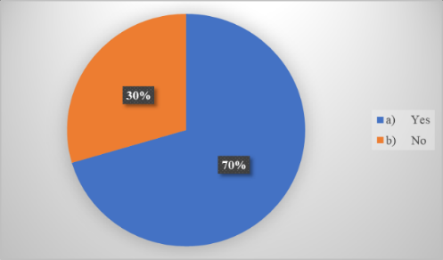

Figure 2
Frequency of AI Use in English Language Learning
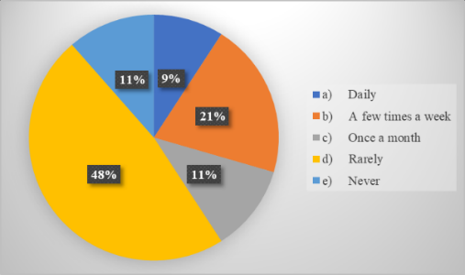
Figure 1 shows that a large number of respondents (70%) reported having used AI to help with their English learning, whereas 30% stated that they had not. Such results indicate that, overall, the use of AI is fairly common among students. When asked about the frequency of AI use for learning English, as in figure 2, participants’ responses showed a certain variation. Only 9% reported using AI on a daily basis, while 20% indicated using it a few times per week, and a smaller proportion (11%) used AI once a month. In contrast, the majority of respondents (48%) reported using AI only rarely, and 11% stated that they never use it. This suggests that while many students have tried AI, most do not use it on a regular basis, and daily or consistent use is still the exception rather than the rule.
Figure 3
Purposes of AI Use in English Language Learning
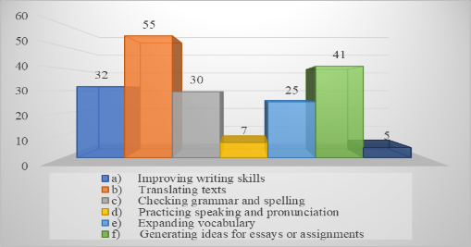
In figure 3, students use AI for English learning in a variety of ways. In fact, the most common use is translating texts, which was reported by 55% of participants. Also, many students use AI to improve their writing skills (32%) and to check grammar and spelling (30%). On the other hand, generating ideas for essays or assignments (41%) and expanding vocabulary (25%) were other fairly uses. In contrast, few students use AI for practicing speaking and pronunciation (7%), and even less, 5% reported other not mentioned uses. Taken together, these results indicate that students primarily rely on AI for text-based tasks, yet its use for speaking and pronunciation remains very low.
Figure 4
Use of AI for English Assignments
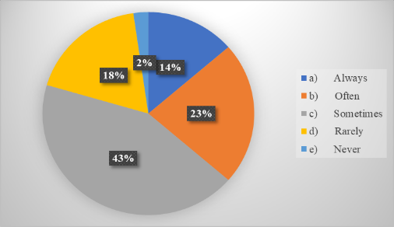
When participants were asked about using AI to assist with English assignments, figure 4 show that 43% of them reported that they sometimes use it, 23% indicated that they often do, and 14% stated that they always use it. Meanwhile, 18% reported rarely using AI , and just 2% mentioned they have never used it for assignments. In fact, this suggests that, as many students rely on AI for assignment support, it is not a consistently used tool, because the majority engage with it only occasionally or off and on.

Figure 5
Methods of AI Use for English Assignments
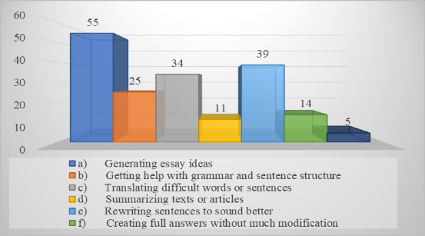
Students use AI for assignments in multiple ways and the most common use selected by 24%, was generating essay ideas. Rewriting sentences to sound better was mentioned by 17% and translating difficult words or sentences was chosen by 15% of students. Other uses included getting help with grammar and sentence structure was reported by 11%, summarizing texts or articles was chosen by 5%, and creating full answers without much modification was reported by 6%. In fact, this shows that AI is primarily used for brainstorming and improving written content, with fewer students relying on it for direct rewriting or generating full responses.
Figure 6
Perceptions of AI Use in Assignments as Academic Dishonesty
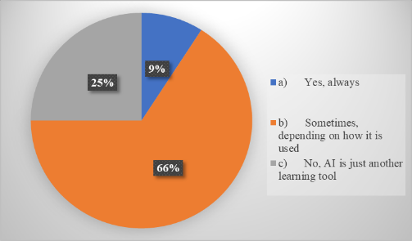
When students were asked about whether using AI for assignments constitutes cheating, 66% expressed that it depends on how it is used. a quarter of students felt that AI is just another learning tool and does not really count as cheating. However, 9% felt that using AI for assignments is always a form of cheating. Most students, it seems, view AI to be used wisely in learning, though a smaller number see it as an unfair shortcut.
Figure 7
Impact of AI on Assignment Completion
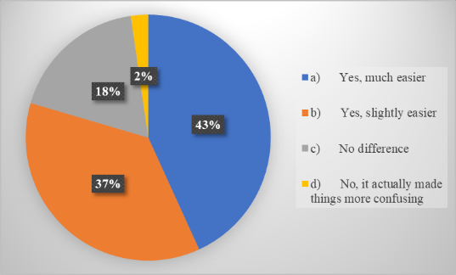
When asked about AI's impact on completing assignments, most respondents responded positively, 43% said it has made assignments much easier, and 36% found it slightly easier. However, 18% stated that there was no difference in the ease of completing assignments, and only 2% found AI to be more confusing. All in all, it seems that most students appreciate what AI brings to their learning, as the majority reported some level of improvement in how easily they get their assignments done.
Figure 8
Perceived Usefulness of AI Tools in English Learning
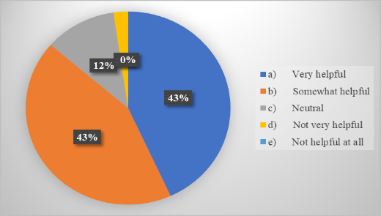
The majority of students (43%) found AI very helpful for learning English, while another 43% considered them somewhat helpful. 11% expressed a neutral stance on the usefulness of AI, and only 2% found them not very helpful. On the other hand, no students reported that AI tools were not helpful at all. As a matter of fact, this indicates that most students view AI as a beneficial resource for learning English, with a significant portion seeing it as very helpful, though a smaller group most students seem to appreciate AI as a useful aid in learning English, many finding it quite helpful, though a smaller group seem like they have not quite made up their mind.
Figure 9
Effect of AI Tools on English Language Skill Development
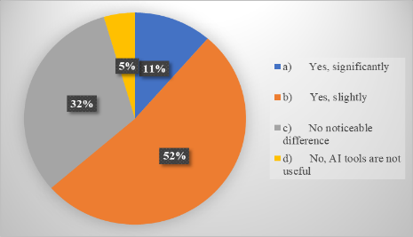
As far as the impact of AI tools on their English skills is concerned, 52% of students reported that AI has improved their skills slightly, while 11% felt their skills have improved significantly. 32% observed no noticeable difference, and 5% found that AI tools are not useful for improving their English. So, while AI does seem to have helped many students with their English, the improvement most of them describe is relatively limited, with fewer reporting any major gains.
Figure 10
Perceptions of AI and Student Dependence on Technology
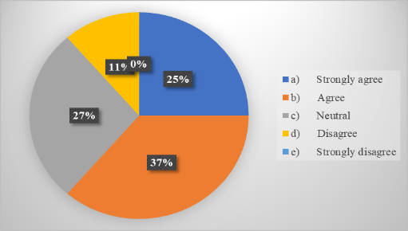
When students were asked if AI can make them dependent on technology instead of learning, 36% agreed, and 25% strongly agreed. Meanwhile, 27% were neutral on the matter, and 11% disagreed. No students strongly disagreed with the statement, and this shows evidence of how that a majority of students recognize the potential for AI to create dependency on technology, although almost half remain neutral or disagree.

Figure 11
Perceptions of the Accuracy and Reliability of AI-Generated Responses
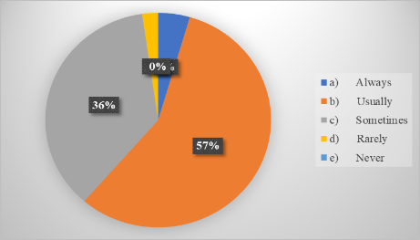
In terms of the accuracy and reliability of AI-generated responses, 57% believed that AI responses are usually correct, while 36% considered them to be sometimes reliable, only 5% felt that AI-generated responses are always correct, and 2% believed they are rarely reliable. In fact, no students thought AI responses were never reliable. This suggests that while most students trust AI-generated responses to some extent, they recognize that the accuracy may not always be guaranteed.
Figure 12
Submission of AI-Generated Content Without Significant Modification
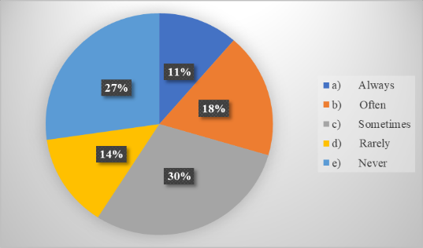
When asked about submitting AI-generated content for assignments without making significant changes, 30% of students reported doing so sometimes, while 18% said they do so often and 11% always submit AI-generated content with little modification. 14% said they rarely do this, and 27% never submit AI-generated content without changes. This suggests that a portion of students use AI-generated content directly for assignments, though most students either make modifications or avoid submitting it unaltered.
Figure 13
Perceived Impact of AI on Students’ Critical Thinking Skills
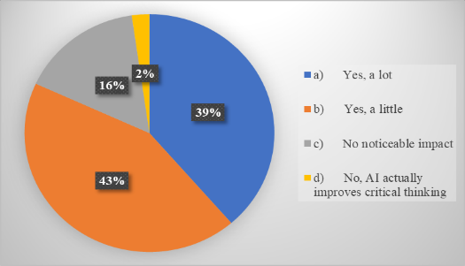
When it comes to the impact of AI on students' critical thinking skills, 43% of them believe AI could have a small effect, while 39% feel it could negatively affect it a lot. 16% observed no noticeable impact, and only 2% thought that AI actually improves critical thinking. Most students appear to be concerned that AI could interfere with critical thinking, with the majority believing it may have at least some negative effect.

Figure 14
Students’ Concerns Regarding AI Use in English Learning
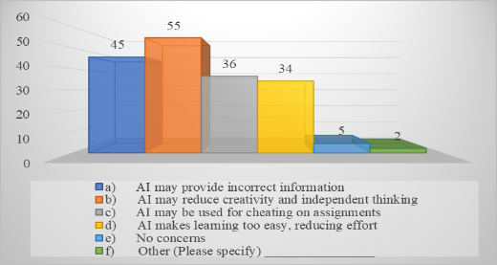
The biggest worry students had about using AI for English learning was that it might reduce their creativity and ability to think for themselves; in fact, a concern raised by more than half of them. A portion of 45% reported that AI may provide incorrect information, while 36% were concerned about AI being used for cheating on assignments. 34% felt that AI makes learning too easy, reducing effort, and only 5% expressed no concerns, and 2% selected other concerns. This shows that students' main concerns came down to three things: AI holding back creativity, enabling academic dishonesty, and making them too dependent on technology.
Figure 15
Student Interest in Greater Integration of AI in English Learning
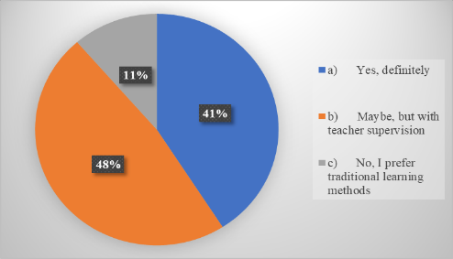
Whereas concerning the application of the AI in learning English at schools, 48% of the participants expressed willingness to employ AI in a situation when a teacher oversees its application; 41% of the respondents indicated their desire for the employment of AI to become even more evident; and finally, 11% said they would prefer conventional methods of teaching. As seen, while students are obviously enthusiastic about employing AI into English learning process at schools, they consider it necessary to have a teacher involved for control purposes.
  - Teachers’ Questionnaire
Figure 16
Teaching Experience in English Language Instruction
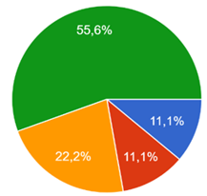
The answers in relation to years of experience indicate a variety of experience in teaching. Most of the respondents, five, have taught English for over 20 years. Two respondents have taught English for 11 to 20 years; one respondent has taught English from 5 to 10 years; while another has been teaching for less than 5 years. These findings paint a picture of a fairly experienced group, more than half of the participating teachers had over two decades in the classroom

Figure 17
Familiarity with AI Tools for English Learning
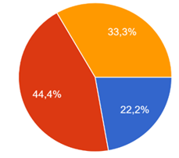
Figure 18
Perceptions of Student Use of AI in English Learning
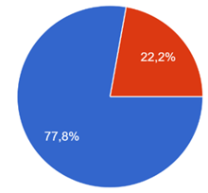
As for familiarity with AI for English learning in figure 17, the teachers' responses were mixed. Just under half, four, described themselves as somewhat familiar with these tools, while two felt very comfortable with them. However, a third of the teachers admitted they had no real familiarity with these tools at all. Overall, while a good number of teachers have at least brushed up against AI in their teaching context, a portion still have little to no real engagement with these technologies. Still, when it came to how students use AI for English learning, teachers reflected a clear image, as figure 18 shows. Most teachers said their students use AI fairly regularly, while the remaining two felt it was only used by some. None of the teachers were unaware of AI use among their students altogether. This suggests that AI has become a widely recognized presence in the English learning process, even if a small number of teachers perceive its use as limited to certain students rather than the class as a whole.
Figure 19
Teacher Recommendations of AI Tools for English Learning
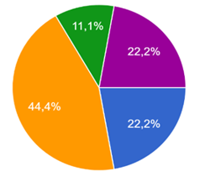
Despite the teachers' mixed use and perception of students' adoption of it, two of teachers, who are a considerable share, have sometimes recommended them to students for improving their English skills, while two always suggest AI tools to students. However, one rarely recommends them, and another two never recommend AI tools for English learning. As a matter of fact, while certain teachers are on board with pointing students toward AI, a good number still hold back, either rarely making such recommendations or steering clear of them entirely.

Table 1
Teachers’ Perceptions of AI Tools Used by Students in English Learning
ChatGPT | Grammarly | Google Translate | Duolingo | Quillbot | None
88,9% | 22,2% | 44,4% | 33,3% | 0% | 0%

When asked about the AI platforms, teachers are of the opinion that students are using it for English learning, the most commonly mentioned one was ChatGPT, with 8 of the teachers out of nine identifying it as a frequently used resource. Google Translate was also noted by four teachers, followed by Duolingo, which was mentioned by three. Lastly, Grammarly was mentioned by two teachers, while QuillBot was not identified by any teacher. Overall, these findings emphasize how that ChatGPT is regarded as the most prominent AI platform for English learning among students.
Figure 20
Teachers’ Use of AI Tools in English Instruction
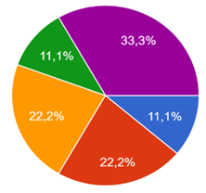
Concerning the use of AI tools in their own teaching, two of the teachers reported using AI tools often, while another two use them sometimes. One teacher always uses AI, and another uses it rarely. However, three reported to never using AI in their teaching. These outcomes reveal that while some teachers actively incorporate AI into their teaching practices, a large share do not use it at all.
Table 2
Methods of AI Integration in English Teaching
Generating Lesson Plans | 22,2%
Creating Grammar and Vocabulary Exercises | 44,4%
Providing Students With AI-Based Feedback | 33,3%
Enhancing Reading Comprehension Exercises | 55,6%
I Do Not Use AI | 33,3%

Among the teachers who use AI in their teaching, the most common use is enhancing reading comprehension exercises, with five selecting this option, and creating grammar and vocabulary exercises is another popular use, mentioned by four of them. Additionally, three use it to give students AI-assisted feedback, and two use it to help plan their lessons. Lastly, three selected not using AI in their teaching at all. These results imply that some teachers are using AI to enhance specific areas of their teaching, such as reading comprehension and exercises, yet a number of teachers are not yet incorporating AI into their practices.

Figure 21
Teachers’ Perceptions of the Effectiveness of AI Tools in English Learning
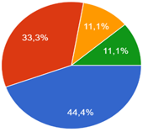
In relation to the efficacy of the usage of AI in making the process of English language learning by learners more efficient, four teachers believed that AI is extremely effective, whereas three believed that AI is somewhat effective. Just one teacher believes that AI tools are neither particularly effective nor particularly ineffective, while another teacher thinks that AI tools are not very effective. Nevertheless, no teachers expressed an opinion that AI tools are not at all effective.
Table 3
Teacher Perspectives on AI’s Contribution to English Learning
Writing Skills | Grammar and Sentence Structure | Speaking and Pronunciation | Vocabulary Building | Reading and Comprehension | AI Does Not Help Students
33,3% | 33,3% | 11,1% | 66,7% | 55,6% | 0%

In the view of the teachers, vocabulary building is the area that receives the maximum improvement through the use of AI, with six of them pointing this out. Another skill is reading comprehension, which was mentioned by five teachers. In addition, three teachers chose both writing skills and grammar and sentence structures as those areas where AI can be helpful. Meanwhile, only one teacher selected that speaking and pronunciation are improved by using AI . There were no teachers who claimed that AI does not help students in their studies.
Figure 22
Teachers’ Perceptions of AI in Supporting Personalized Learning
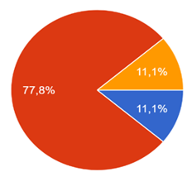
When asked about AI's potential to improve personalized learning for students, the majority of teachers, represented by seven, believed that AI can enhance personalized learning to some extent. One teacher was of the opinion that AI could highly enhance personalized learning, while another disagreed, believing that traditional methods are better for personalization. These results show that a large share of teachers acknowledge the ability of AI in supporting such type of learning, although opinions are mixed when it comes to the degree of its impact compared to traditional methods.

Figure 23
Teachers’ Observations of Student Use of AI in Assignments
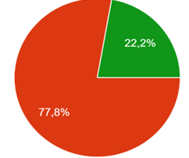
Regarding students’ use of AI for assignments, seven reported noticing that students tend to use AI for assignments. On the other hand, a smaller percentage of two observed that it is rarely used, while no teachers stated that they have seen students using AI always, sometimes, or never. These results suggest that AI use for assignments is fairly common.
table 4
Teachers’ Perceptions of How Students Use AI in Assignments
Generating Entire Essays or Paragraphs | 88,9%
Getting Ideas for Writing | 22,2%
Checking Grammar and Improving Sentence Structure | 22,2%
Translating Texts | 66,7%
Summarizing Reading Materials | 22,2%

According to the teachers, the most common way students use AI in their assignments is by generating entire essays or paragraphs, as stated by 8 teachers. Additionally, translating texts is another popular use that was mentioned by six teachers. While getting ideas for writing, checking grammar and improving sentence structure, and summarizing reading materials were each identified by two only of teachers as ways in which students use AI for assignments. Students appear to turn to AI mostly for content generation, though many also use it for translation, grammar improvement, brainstorming ideas, and summarizing texts.
Figure 24
Incidents of Students Submitting AI-Generated Work
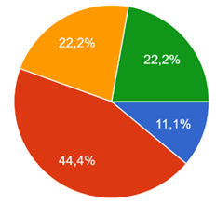
Regarding whether teachers have caught students submitting AI-generated work as their own, four reported that it generally happens, while a lesser amount of two said it sometimes and rarely occurs. However, only one stated they have always caught students doing this, and no teachers reported they have ever encountered this issue. It turns out that quite a few teachers have already seen students hand in AI-generated work, and for some, this is something they come across fairly often.

Figure 25
Teacher Concerns Regarding AI and Academic Dishonesty
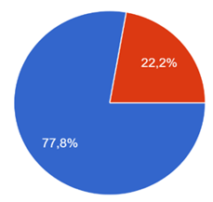
When asked about their concerns regarding AI and academic dishonesty, a vast majority of seven teachers expressed being very concerned about AI encouraging academic dishonesty while only two were somewhat concerned. No teachers reported being neutral, not very concerned, or not concerned at all. As a matter of fact, this data indicates that most teachers are quite worried about what AI means for academic honesty, the threat it poses to academic integrity is something that clearly sits at the front of their minds.
Table 5
Measures to Prevent AI Misuse in Assignments
Educating Students about Responsible AI use | 66,7%
Designing Assignments that Require Critical Thinking and Creativity | 66,7%
Using AI Detectors to check Students Submissions | 33,3%
Encouraging Handwritten Work for Some Assignments | 33,3%

To prevent AI misuse in assignments, six of the teachers pointed to two measures, educating students about responsible AI use, and designing tasks that demand critical thinking and creativity. Additionally, using AI detection and encouraging handwritten work for some assignments were each chosen by three. Most teachers appear to prefer getting ahead of AI misuse rather than reacting to it, with educating students and rethinking assignment design being their focus. That said, detection measures and handwritten work are still considered cherished backup measures.
Figure 26
Integration of AI Tools in School English Learning
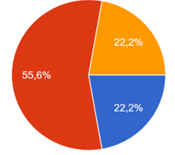
When inquired about the integration of AI into English learning at school, five teachers, who are over half the teachers, believe that AI should be used, but with strict guidelines. Additionally, two support the idea that AI should be actively used in education, while another two feel that AI should not replace traditional learning methods. While teachers generally support bringing AI into education, most stress the importance of doing so carefully and with clear guidelines in place to govern its use.

Figure 27
Teacher Training on the Role of AI in Education
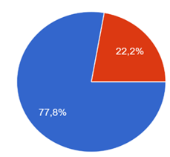
A commanding majority of seven teachers believe that teachers should receive training on AI’s role in education while a minor group of only two feel that training would be necessary only if AI becomes widely used. However, no teachers felt that AI training is unnecessary. These results reflect a strong endorsement for professional development in AI for educators, with most teachers acknowledging the importance of being prepared for its increasing and growing role in education.
  - Recommendations for the Responsible Use of AI in English Learning
In general, teachers appeared to embrace AI technology in English language learning, yet were concerned about some issues. The recurring issue for them was that AI was to help students learn rather than replace students' efforts in learning. For example, teacher Regis noted that AI was to be used as “a supplement [of teaching], AI should support learning, not replace critical thinking or real communication.” Also, teacher Rhezlane highlighted that it was crucial how AI was employed as she underlined, “using it only on purpose, checking all the work generated and ‘keep thinking, reflecting '.”
Ethical responsibility was highlighted again and again from most of the responses collected. The educators highlighted that the learners need to be held accountable for what they turn in irrespective of the extent of use of AI in the submitted assignments. According to educator Ghislain, "students should take ownership for their work and recognize their work integrity whether they use AI or not in their assignment." Similarly, another teacher, Regis, highlights the ethical application of the technology by emphasizing the need for educators to "promote Ethical Use: Avoid plagiarism by ensuring AI-generated work is properly edited and cited." From the responses received, it is clear that issues surrounding ethics and integrity are of great concern to many teachers.
However, some teachers also argued that using artificial intelligence moderately with boundaries would be appropriate. For example, teacher Imane advised teachers to “use it with moderation,” which implies that excessive reliance on the technology can prevent students from learning. In addition, teacher Regis discussed his point and stated that “set Clear Boundaries: Define when AI tools are acceptable, e.g., for grammar checks but not full essay writing.” Thus, teachers agree that AI can be used with limits, meaning that its application in academic processes should be moderate. It is necessary to use the tool only in certain aspects, and teachers do not allow it to do all the academic work.
Other themes that were highlighted include the importance of educating students on how to use AI correctly. According to Teacher Kimberly, it was very important to “educate students on correct use of AI when setting goals.” Essentially, this means that students were required to be educated on how to effectively use AI as part of their academic learning journey. The increasing role of AI in educational institutions suggests that it is now more important than ever for everyone to gain digital and AI literacy skills.
In spite of all these favorable suggestions, one teacher still had doubts regarding younger students utilizing AI. Teacher Caroline believes that “Kids are not mature enough to use AI as a learning skill; they use it as a tool to do their work without actually doing it themselves.” This indicates that certain methods would have to be employed in order to ensure that AI is a means of learning and not avoidance of studies.
- Discussion
The reason of this study was to explore students' and teachers’ perceptions of AI in English language learning, with attention to its benefits, limitations, ethical concerns, and implications for education. The results revealed a compound yet broadly favorable stance toward AI, with some concerns about academic integrity and over-reliance. This section discusses these results in light of the existing literature.

  - Students’ Engagement with and Perceived Benefits of AI
These findings show that an overwhelming number of students have engaged with AI technologies (70%), although most do this rarely, with only a small percentage engaging in this frequently, and this is supported by Liu et al. (2024) and Phan (2023). They observed that even though the students are very much open to accepting AI devices into their lives, they are not yet using them in their studies. The students are mainly using AI technology to translate, create ideas, write and check grammar, thus corroborating other literature showing how students see AI as a multi-functional assistant in writing and language tasks.
Students’ strong belief in AI’s usefulness (86% “very” or “somewhat” helpful) supports findings from Sumakul et al. (2021), which show that AI enhances motivation, reduces anxiety, and supports productivity. Notably, more than half of the students reported improvements in their English skills, though mostly moderate. This aligns with studies that suggest that AI enhances language acquisition in targeted areas such as vocabulary, grammar, and fluency (Gao & Izadpanah, 2023; Liang et al., 2023).
On the other hand, the relatively low usage of AI for speech (7%) corresponds with issues raised in the literature where text-based systems are viewed to hinder the improvement of oral skills (Belda & Calvo, 2022). In fact, this suggests that although students acknowledge the usefulness of AI in writing-related tasks, they have not yet made use of those that enhance oral skills.

  - Concerns About Dependence, Reliability, and Critical Thinking
Despite the optimistic attitudes, students voiced reservations about what AI can negatively cause. The Majority were of the view that AI risks pushing students towards a dependence on technology, which echoed fears raised by Chambers (2020), Shidiq (2023), and Darvishi et al. (2024) about reduced learner autonomy. Moreover, other concerns emerged around creativity and independent thinking, with 55% identifying them as the primary risk. This study agrees with the conclusions reached by Kim et al. (2024) and Fornet & Rea (2024) in that depending too much on AI could cause the mental exertion on the part of the learners to be reduced. What is noteworthy about this is that although students trust the information presented by AI, they are generally aware that even this technology is prone to providing inaccurate results. It is a promising sign that students are developing some degree of AI literacy, but it also serves as a reminder that this awareness alone is not enough, and proper educational guidance still needs to be there to support it.

  - Students’ Ethical Perceptions and Academic Integrity Risks
Indeed, issues of ethics were of concern to the students, particularly with regards to cheating. However, it should be noted that the majority of respondents (66%) did not consider the use of AI technologies as unethical but argued that everything depended on how they were used, and in this sense, the approach was rather critical. This statement agrees with the ideas presented by Rogerson and McCarthy (2017) and Neff et al. (2024), as they noted such ambiguity in the understanding of boundaries between permissible help and unethical replacement by AI. Moreover, some respondents reported using AI-written texts with little modifications, which is consistent with Cotton et al. (2023). They refer to AI as “chatting and cheating” (p.228). When paired with teachers' observations of frequent plagiarism that is based on AI, these results reveal a real tension. Students appreciate AI for the efficiency it brings, but many appear to struggle with knowing where to draw the ethical line.

  - Teachers’ Recognition of AI’s Pedagogical Value
Teachers largely saw promise in AI for supporting English learning, with over 75% rating it effective or highly effective. Consistent with Zainuddin (2024) and Govindarajoo et al. (2025), teachers saw value in AI's ability to shape tasks around learners, return quick feedback, and stir motivation, particularly when it comes to vocabulary and reading comprehension. These findings are consistent with what has been claimed by students regarding the efficacy of AI in such instances, ensuring that the benefits of AI in education have been recognized by both parties. However, it has become apparent that teachers were not in agreement about their knowledge of AI, as some were more knowledgeable about the topic than others, an issue addressed by Soledispa et al. (2023) and Subramaniam and Yasin (2024). And this is not without consequence, as without complete confidence with regards to AI, teachers cannot direct their students towards the appropriate use of it.

  - Teachers’ Concerns: Misuse, Over-Reliance, and Equity
Academic dishonesty weighed heavily on teachers' minds, with nearly 80% expressing significant anxiety about AI misuse. This is very much in line with what Akgun and Greenhow (2022) and Kasneci et al. (2023) have argued that large language models introduce new integrity challenges that educational institutions are still figuring out how to handle. The teachers were equally concerned about the deterioration of critical thinking abilities among students caused by the use of AI, an issue which, according to Ulla et al. (2023), was a matter of concern for students, too. That students use AI to write the whole essay is a finding that aligns with other teachers who reported similar issues with the use of AI by their students. Apart from being worried about academic integrity and the development of critical thinking abilities, there appears to be another issue lying below the surface. It is that of the inequalities surrounding the access to AI devices.

  - Convergence and Divergence Between Students and Teachers
Among others, one of the main outcomes of this study is the identification of similarities and differences in perceptions by the two sides. To start with, both sides recognize the importance of the application of AI in English learning. In addition, both parties are concerned about the possibility of a reduction in their abilities to think critically and creatively. Also, both know that there are ethical challenges when using AI.
However, learners perceive AI as something practical that can help them learn. Teachers, on the other hand, are primarily concerned with ethics as well as the effect that AI technology may have on their pedagogy. Additionally, learners feel that there have been moderate improvements in their language skills, while teachers highlight the potential that AI has in developing particular language skills. Finally, teachers feel that academic misconduct is a major issue, probably owing to the firsthand experience they have had of detecting cases of such misconduct using AI.

- Conclusion
This study examined students and teachers’ perceptions of AI in English language learning, and revealed a view of both enthusiasm and caution. The results demonstrate that AI is widely used and valued by students for tasks such as translation, writing, grammar checking, and idea generation. Most students acknowledge that AI makes assignments easier and can improve their English skills. However, many also flag some genuine worries, including the possibility that AI could hold back creativity, make students too dependent on technology, and occasionally lead them astray with inaccurate or misleading information.
Teachers, too, acknowledge the value of AI in education, specifically in relation to personalized learning, vocabulary acquisition, and reading comprehension. While all these benefits sound positive, they come with fears regarding academic integrity, issues related to cheating, loss of critical-thinking skills, accessibility to AI technology, and the temptation for students to use it in writing full papers. Ethical dilemmas, of course, are no surprise here as teachers themselves have had experience with the problem of plagiarized content through AI and the struggle to teach students what constitutes proper usage.
On the whole, some similarities as well as differences can be seen from this study, such as the usefulness of AI with regulation, but teachers' concerns over its use compared to those of students. In general, all these findings indicate the importance of having policies as well as guidelines for using AI responsibly, and learning about AI by all students and teachers. In summary, incorporating AI in English education requires not only having AI but also being ethically aware as well as being a competent teacher.

  - Limitations of the Study
While the results of the study are quite intriguing, there is still a need to note certain limitations of the study. Firstly, the sample size used for conducting the experiment was 42 students and 9 teachers from one and the same educational institution. Such a sample size, even though useful for drawing conclusions, is too limited for extending the results of the research to broader audiences and different settings. In terms of methodology, although numerical data were obtained by means of questionnaires, no qualitative interviews were used, which might explain some participants' behaviors. Additionally, all answers given by students and teachers were influenced by their own personal perceptions. Therefore, self-reporting may introduce bias, particularly regarding topics like academic dishonesty and AI misuse. In addition,
while the study explored beliefs about AI’s usefulness, it did not measure actual language learning outcomes or compare student performance with and without AI use. And lastly,
AI instruments develop quickly, meaning that perceptions measured at one point in time may shift, as new sets emerge or awareness of AI capabilities evolves.

  - Recommendations for Future Research
Given the growing importance of AI in education and the limitations outlined above, several directions for future research are recommended. The study should have included larger and more diverse samples
studies via incorporating multiple schools, or regions, which would have allowed for broader generalization and views into differences in AI adoption. Second, it should have expanded research to mixed-methods or qualitative designs
interviews, focus groups, and classroom observations could provide deeper views into how students and teachers use AI in practice, and how they view ethical boundaries. The following then, in the examination of the true effect that AI technology may have on English competence, could have been considered. Furthermore, in the future, researchers can focus on assessing the outcomes of language skills development like learning of new vocabulary or improvement in writing or speaking as ways of determining whether any improvements actually translate into observable outcomes. Fourthly, in order to assess decision making in ethical terms and the implementation of policies, future research can be done by observing how the students interpret, accept, or disobey the policies and how the teachers enforce them. Sixth, since AI use is currently limited to speaking and pronunciation, research could explore how speech-based AI features influence oral fluency, pronunciation accuracy, and communicative confidence. Lastly, longitudinal studies could examine whether sustained AI use influences creativity, critical thinking, problem-solving, and writing independence over time.

Funding: This research received no external funding.
Conflicts of Interest: The authors declare no conflict of interest.
Publisher’s Note: All claims expressed in this article are solely those of the authors and do not necessarily represent those of their affiliated organizations, or those of the publisher, the editors and the reviewers.

References
- Ahmed, K., Akhter, S., Siwok, S. R., Tambi, F., Ahmed Khan, A., & Farooqi, U. U. (2025). Role of ChatGPT in enhancing English language learning: A case study of University students. Forum for Linguistic Studies, 7(7), 460-469. https://doi.org/10.30564/fls.v7i7.9165
- Akgun, S., & Greenhow, C. (2021). Artificial intelligence in education: Addressing ethical challenges in K-12 settings. AI and Ethics, 2(3), 431–440. https://doi.org/10.1007/s43681-021-00096-7
- Algaraady, J., & Mahyoob, M. (2023). ChatGPT’s capabilities in spotting and analyzing writing errors experienced by EFL learners. Arab World English Journal (AWEJ), 9, 3–17. https://doi.org/10.24093/awej/call9.1
- Anjum, F., Raheem, R., & Ghafar, N. (2024). The impact of ChatGPT on enhancing students’ motivation and learning engagement in second language acquisition: Insights from students. Journal of e-learning Research, 3(2), 1–11. https://doi.org/10.33422/jelr.v3i2.679
- Baker, T., & Smith, L. (2019). Educ-AI-tion rebooted? Exploring the future of artificial intelligence in schools and colleges. Nesta . Nesta. https://www.nesta.org.uk/report/educ-ai-tion-rebooted/
- Barrett, A., & Pack, A. (2023). Not quite eye to A.I.: Student and teacher perspectives on the use of generative artificial intelligence in the writing process. International Journal of Educational Technology in Higher Education, 20(1), 1-24. https://doi.org/10.1186/s41239-023-00427-0
- Belda, J., & Calvo, R. (2022). Using chatbots as AI conversational partners in language learning. Applied Sciences, 12(17). https://doi.org/10.3390/app12178427
- Bibi, Z., & Atta, A. (2024). The role of ChatGPT as an AI English writing assistant: A study of students’ perceptions, experiences, and satisfaction level. Annals of Human and Social Sciences, 5(1), 433–443. https://doi.org/10.35484/ahss.2024(5-I)39
- Çela, E., Fonkam, M. M., & Potluri, R. M. (2024). Risks of AI-assisted learning on student critical thinking. International Journal of Risk and Contingency Management, 12(1), 1-19. https://doi.org/10.4018/ijrcm.350185
- Chambers, A. (2020). AI and language learning: Opportunities and challenges. Language Learning & Technology, 24(3), 12–26.
- Cohen, L., Manion, L., & Morrison, K. (2018). Research methods in education (8th ed.). Routledge.
- Cotton, D. R., Cotton, P. A., & Shipway, J. R. (2023). Chatting and cheating: Ensuring academic integrity in the era of ChatGPT. Innovations in Education and Teaching International, 61, 1–12. http://doi.org/10.1080/14703297.2023.2190148
- Creswell, W., & Creswell, D. (2018). Research design: Qualitative, quantitative, and mixed methods approaches. SAGE Publications.
- Creely, E. (2023). The possibilities, limitations, and dangers of generative AI in language learning and literacy practices. International Graduate Research Symposium 2023 Proceedings, University of Languages and International Studies (ULIS), Hanoi, Vietnam.1-14
- Darvishi, A., Khosravi, H., Sadiq, S., Gasevic, D., & Siemens, G. (2024). Computers & education, 210, 1–18. http://doi.org/10.1016/j.compedu.2023.104967
- Dörnyei, Z. (2007). Research methods in applied linguistics: Quantitative, qualitative and mixed methodologies. Oxford University Press.
- Dovgyi, S., Babiichuk, S., Davybida, L., & Biletska, M. (2024). Teachers’ and students’ attitudes towards the use of artificial intelligence: All-Ukrainian research. Information Technologies and Learning Tools, 104(6), 197-215. https://doi.org/10.33407/itlt.v104i6.5890
- Etikan, I., Musa, S. A., & Alkassim, R. S. (2016). Comparison of convenience sampling and purposive sampling. American Journal of Theoretical and Applied Statistics, 5(1), 1–4. https://doi.org/10.11648/j.ajtas.20160501.11
- European Commission. (2022). Ethical guidelines on the use of artificial intelligence (AI) and data in teaching and learning for educators. https://data.europa.eu/doi/10.2766/153756
- Fang, L. (2025). The impact of AI tools on ESL learners’ engagement and language learning motivation. Journal of Education and Educational Research, 12(3), 111-114. https://doi.org/10.54097/hvm6w044
- Fathi, J., Rahimi, M., & Derakhshan, A. (2024). Improving EFL learners’ speaking skills and willingness to communicate via artificial intelligence-mediated interactions. System. https://doi.org/10.1016/j.system.2024.103254
- Fornet, L., & Rea, A. (2024). AI-driven academic writing: Benefits and limitations. Studies in Applied Linguistics, 39(1), 45–67.
- Fraenkel, J. R., Wallen, N. E., & Hyun, H. H. (2019). How to design and evaluate research in education (10th ed.). McGraw Hill Education.
- Gao, F., & Izadpanah, S. (2023). The relationship between computer games and computer self-efficacy with academic engagement: The mediating role of students’ creativity. Education and Information Technologies, 28(11), 14229–14248. https://doi.org/10.1007/s10639-023-11757-x
- Godwin, R. (2021). AI and language learning: Transforming instruction. Language Teaching Research, 25(4), 567–589.
- Govindarajoo, M. V. V., Nair, S. M., Sekhon, R. S., Wai, C. S., Hoong, L. C., Huat, T. B., & Okawa, T. (2025). Exploring teachers’ views on benefits, ethical issues, and challenges in integrating AI tools in Malaysian schools. Edelweiss Applied Science and Technology, 9(9), 699–710. https://doi.org/10.55214/2576-8484.v9i9.9935
- Gravetter, F. J., & Wallnau, L. B. (2017). Statistics for the behavioral sciences (10th ed.). Cengage Learning.
- Gupta, I. C., & Mazumdar, S. (2024). Influence of AI technology in education in education, technology, and sustainability. BlueRoseONE.
- Habibulloh, M. (2025). Ethics of artificial intelligence usage in education: A qualitative study on teachers' and students' perceptions. International Journal of Interdisciplinary Research, 1(1), 1-11. https://doi.org/10.71305/ijir.v1i1.222
- Javaid, Z. K., Ramzan, M., & Ijaz, S. (2024). A systematic review on cognitive and motivational impact on English language learning through artificial intelligence. International Journal of Literature, Linguistics and Translation Studies, 4(1), 44–71. https://doi.org/10.37605/ijllts.v4i1.4
- Karataş, F., Abedi, F. Y., Ozek Gunyel, F., Karadeniz, D., & Kuzgun, Y. (2024). Incorporating AI in foreign language education: An investigation into ChatGPT’s effect on foreign language learners. Education and Information Technologies, 29(15), 19343-19366. https://doi.org/10.1007/s10639-024-12574-6
- Kasneci, E., et al. (2023). ChatGPT for good? On opportunities and challenges of large language models for education. Learning and Individual Differences, 103, 1-13.
- Keleş, P. U., & Aydın, S. (2021). University students’ perceptions about artificial intelligence. Shanlax International Journal Education, 9(S1), 212–220. https://doi.org/10.34293/education.v9iS1-May.4014
- Khzouz, A., Salaita, O., Al-Issawi, J. M., AlTaher, B. B., & Alkhenizan, H. H. (2024). Exploring ChatGPT practices and user experiences in learning English skills. Theory and Practice in Language Studies, 14(12), 3959-3969. https://doi.org/10.17507/tpls.1412.31
- Kim, J., Yu, S., Detrick, R., & Li, N. (2024). Exploring students’ perspectives on Generative AI assisted academic writing. Education and Information Technologies, 30(1), 1265–1300. https://doi.org/10.1007/s10639-024-12878-7
- Khoso, A. K., Wang, H., & Darazi, M. A. (2025). Empowering creativity and engagement: The impact of generative artificial intelligence usage on Chinese EFL students’ language learning experience. Computers in Human Behavior Reports, 18, 1-14. https://doi.org/10.1016/j.chbr.2025.100627
- Kurniati, E. Y., & Fithriani, R. (2022). Post-graduate students’ perceptions of Quillbot utilization in English academic writing class. Journal of English Language Teaching and Linguistics, 7(3), 437–451. https://dx.doi.org/10.21462/jeltl.v7i3.852
- Li, X., & Huo, Y. (2020). AI and English language learning: A global perspective. ELT Journal, 74(3), 321–337.
- Liang, J., Wang, L., Luo, J., Yan, Y., & Fan, C. (2023). The relationship between student interaction with generative artificial intelligence and learning achievement: Serial mediating roles of self-efficacy and cognitive engagement. Frontiers in Psychology, 14, 1-12. https://doi.org/10.3389/fpsyg.2023.1285392
- Liu, G. L., Darvin, R., & Ma, C. (2024). Exploring AI-mediated informal digital learning of English (AI-IDLE): A mixed-method investigation of Chinese EFL learners’ AI adoption and experiences. Computer Assisted Language Learning, 38(7), 1632–1660. https://doi.org/10.1080/09588221.2024.2310288
- Liu, Y., Chen, L., & Yao, Z. (2022). The application of artificial intelligence assistant to deep learning in teachers' teaching and students' learning processes. Frontiers in Psychology, 13, 929175. https://doi.org/10.3389/fpsyg.2022.929175
- Luo, J. (2024). A critical review of GenAI policies in higher education assessment: A call to reconsider the “originality” of students’ work. Assessment & Evaluation in Higher Education, 49, 1–14. https://doi.org/10.1080/02602938.2024.2309963
- Luckin, R., Holmes, W., Griffiths, M., & Forcier, L. B. (2016). Intelligence unleashed: An argument for AI in education. Pearson.
- Mandal, R., & Mete, J. (2023). Teachers’ and students’ perception towards integration of artificial intelligence in school curriculum: A survey. International Journal of Multidisciplinary Educational Research, 12(7/5), 95–103. https://ssrn.com/abstract=4544750
- MLA-CCCC Joint Task Force on Writing and AI. (2023). Working paper: Overview of the issues, statement of principles, and recommendations. Conference on College Composition and Communication (CCCC) and the Modern Language Association (MLA). https://cccc.ncte.org/mla-cccc-joint-task-force-on-writing-and-ai
- Munir, H., Vogel, B., & Jacobsson, A. (2022). Artificial intelligence and machine learning approaches in digital education: A systematic revision. Information, 13(4), 203. https://doi.org/10.3390/info13040203
- Neff, J., Arciaga, K., & Yamamoto, S. (2024). EFL students’ and teachers’ perceptions of the ethical uses of AI tools. Technology in Language Teaching & Learning, 6(3). https://doi.org/10.29140/tltl.v6n3.1714
- Ng, T., Leung, K., Chu, W., & Qiao, S. (2021). AI literacy: Definition, teaching, evaluation and ethical issues. Proceedings of the Association for Information Science and Technology, 58(1), 504–509. https://doi.org/10.1002/pra2.487
- PAN, J. (2024). AI-driven English language learning program and academic writing integrity in the era of intelligent interface. English Language Teaching and Linguistics Studies, 6(4), 120-135. https://doi.org/10.22158/eltls.v6n4p120
- Panagiotidis, P. (2025). AI-driven applications for language learning: Transformative technologies and educational benefits. EDULEARN Proceedings, 1, 747-758. https://doi.org/10.21125/edulearn.2025.0282
- Phan, T. N. L. (2023). Students’ perceptions of the AI technology application in English writing classes. Proceedings of the AsiaCALL International Conference, 4, 45–62. https://doi.org/10.54855/paic.2344
- Perkins, M. (2023). Academic integrity considerations of AI large language models in the post-pandemic era: ChatGPT and beyond. Journal of University Teaching and Learning Practice, 20(2), 1-24. https://doi.org/10.53761/1.20.02.07
- Rahimi, R., Sheyhkholeslami, M., & Pour, M. (2025). Uncovering personalized L2 motivation and self-regulation in ChatGPT-assisted language learning: A hybrid PLS-SEM-ANN approach. Computers in Human Behavior Reports, 17(1), 1-15. https://doi.org/10.1016/j.chbr.2024.100539
- Reis, O. (2024). Artificial intelligence as a tool to practice and improve speaking and listening skills in English. FALEST.
- Rogerson, A. M., & McCarthy, G. (2017). Using Internet based paraphrasing tools: Original work, patchwriting or facilitated plagiarism? International Journal for Educational Integrity, 13(1), 2. https://doi.org/10.1007/s40979-016-0013-y
- Rusmiyanto, N., Huriati, N., Fitriani, N., Kusumaning, T., Agus, M., & Sari, N. (2023). The role of artificial intelligence (AI) in developing English language learner’s communication skills. Journal on Education, 6(1), 750–757.
- Rybina, N. V., Koshil, N. Y., & Hyryla, O. S. (2025). Artificial intelligence and translation in English language teaching: Opportunities and challenges. Медична освіта, (2), 87-91. https://doi.org/10.11603/m.2414-5998.2025.2.15494
- Salvagno, M., Taccone, F. S., & Gerli, A. G. (2023). Can artificial intelligence help for scientific writing? Critical Care, 27(1), 1–5. https://doi.org/10.1186/s13054-023-04380-2
- Shidiq, M. (2023). The use of artificial intelligence based Chat GPT and its challenges for the world of education: From the viewpoint of the development of creative writing skills. In Proceedings of the International Conference on Education, Society and Humanity, 1(1), 353–357. https://ejournal.unuja.ac.id/index.php/icesh/article/view/5614
- Soledispa, C. J. L., Mantilla Carrera, P. N., Dávila Macías, A. M., Jaramillo Crespo, L. F., & Armijos Solano, D. O. (2023). English teachers’ perspectives on the impact of artificial intelligence in language courses [English version]. Ciencia Latina: Revista Científica Multidisciplinar, 7(4), 8278–8295. https://ciencialatina.org/index.php/cienciala/article/download/7562/11457?inline=1
- Song, C., & Song, Y. (2023). Enhancing academic writing skills and motivation: Assessing the efficacy of ChatGPT in AI-assisted language learning for EFL students. Frontiers in Psychology, 14, 1-14. https://doi.org/10.3389/fpsyg.2023.1260843
- Subramaniam, K., Yasin, M., & Saharuddin, N. (2024, November). The impact of artificial intelligence on teaching and learning: Opportunities and challenges in tertiary education in Klang Valley, Malaysia. In International Graduate Research in Education Seminar 2024 (i-GREduc 2024): Future-ready education: Innovating for tomorrow's challenges (pp. 162–165).
- Sumakul, D. T., Hamied, F. A., & Sukyadi, D. (2022). Students’ perceptions of the use of AI in a writing class. Advances in Social Science, Education and Humanities Research, 624, 52-57. https://doi.org/10.2991/assehr.k.220201.009
- Ulla, M. B., Perales, W. F., & Busbus, S. O. (2023). ‘To generate or stop generating response’: Exploring EFL teachers’ perspectives on ChatGPT in English language teaching in Thailand. Learning: Research and Practice, 9(2), 168–182. https://doi.org/10.1080/23735082.2023.2257252
- Usher, M., & Barak, M. (2024). Unpacking the role of AI ethics online education for science and engineering students. International Journal of STEM Education, 11(1), 1–14.
- Wang, X., Pang, H., Wallace, M. P., Wang, Q., & Chen, W. (2024). Learners’ perceived AI presences in AI-supported language learning: A study of AI as a humanized agent from community of inquiry. Computer Assisted Language Learning, 37(4), 814–840. https://doi.org/10.1080/09588221.2022.2056203
- Weidinger, L., et al. (2021). Ethical and social risks of harm from language models. arXiv preprint arXiv:2112.04359.
- Woo, J. H., & Choi, H. (2021). Systematic review for AI-based language learning tools. Journal of Digital Contents Society, 22(11), 1783–1792. https://doi.org/10.9728/dcs.2021.22.11.1783
- Yaseen, H., Mohammad, A. S., Ashal, N., Abusaimeh, H., Ali, A., & Sharabati, A. A. (2025). The impact of adaptive learning technologies, personalized feedback, and interactive AI tools on student engagement: The moderating role of digital literacy. Sustainability, 17(3), 1-27. https://doi.org/10.3390/su17031133
- Zainuddin, M. (2024). Teachers’ perceptions of AI tools in enhancing student engagement for English language learning. Research Studies in English Language Teaching and Learning, 2(6), 367–380. https://doi.org/10.62583/rseltl.v2i6.64
- Zhai, C., Wibowo, S., & Li, L. D. (2024). The effects of over-reliance on AI dialogue systems on students' cognitive abilities: A systematic review. Smart Learning Environments, 11(1), 1-37. https://doi.org/10.1186/s40561-024-00316-7
- Zhang, S., Zhao, X., Zhou, T., & Kim, J. H. (2024). Do you have AI dependency? The roles of academic self-efficacy, academic stress, and performance expectations on problematic AI usage behavior. International Journal of Educational Technology in Higher Education, 21(1), 1-14. https://doi.org/10.1186/s41239-024-00467-0

